# SAST

Run sonarqube with docker

|  |
| --- |
| docker run -d --name sonarqube -e SONAR\_ES\_BOOTSTRAP\_CHECKS\_DISABLE=true -p 9000:9000 sonarqube:latest  Or  docker run -d --name sonarqube -e SONAR\_ES\_BOOTSTRAP\_CHECKS\_DISABLE=true -p 9000:9000 sonarqube:lts |

sonarqube docker run cannot access port 9000 in website.

|  |
| --- |
| docker run --network=host -e SONAR\_HOST\_URL='http://127.0.0.1:9000' --user="$(id -u):$(id -g)" -v "$PWD:/usr/src" sonarsource/sonar-scanner-cli |

Read logs

|  |
| --- |
| docker logs sonarqube -f |

Reference to read more detail

<https://docs.sonarqube.org/latest/setup-and-upgrade/install-the-server/>

[Java test coverage (sonarqube.org)](https://docs.sonarqube.org/latest/analyzing-source-code/test-coverage/java-test-coverage/)

Go to dashboard with port 9000, after login and add manual maven project

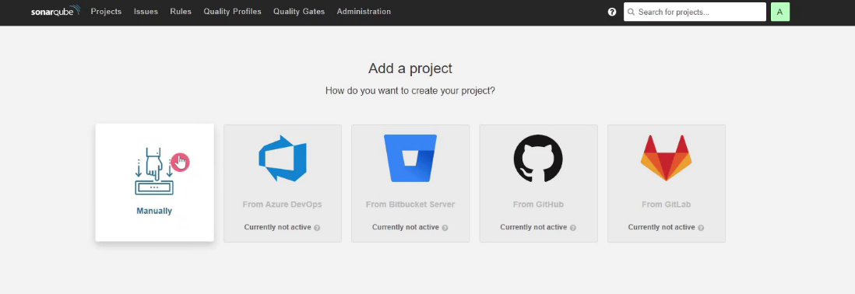

Project key is your project name

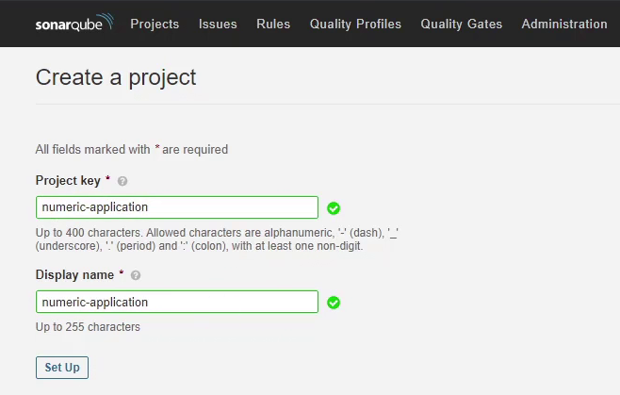

Select maven

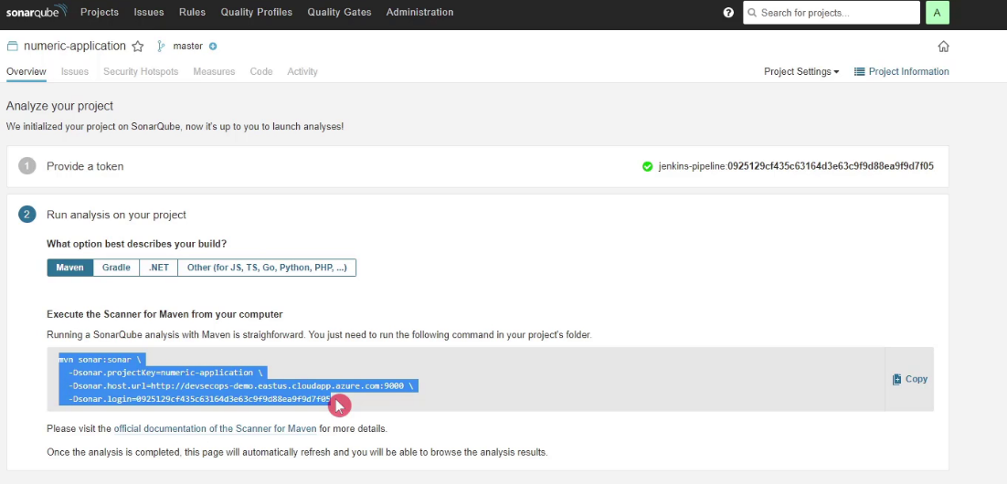

Copy code to jenkins file

|  |
| --- |
| stage('SonarQube - SAST') {  steps {  withSonarQubeEnv('SonarQube') {  sh "mvn clean verify sonar:sonar \  -Dsonar.projectKey=numeric-app \  -Dsonar.host.url=http://192.168.126.132:9000 \  -Dsonar.login=sqp\_76f368be3de38b7cbc9eedcd1f14798bc1a19397"  } |

# SONARQUBE QUALITY GATES

## Generate a token in SonarQube, please follow these steps:

* + Log in to your SonarQube instance as an administrator.
  + Click on your user avatar in the top-right corner and select "My Account" from the dropdown menu.
  + Click on "Security" in the left-hand navigation menu.
  + Click on "Generate Tokens" in the "Tokens" section.
  + Enter a name for your token in the "Name" field.
  + Select the appropriate permissions for your token in the "Permissions" field (e.g. "Execute Analysis" for a token to be used with a CI/CD pipeline).
  + Click on the "Generate" button to generate your token.
  + Copy the token value into that is displayed on the screen and store it in a safe place, as it will not be displayed again.

Projects 
Issues 
Rules 
Quality Profiles 
Quality Gates 
Administration 
Q Search for projects 
A 
Tokens 
Administrator 
Profile 
Security 
Notifications 
Projects 
Administrator 
My Account 
Log out 
If you want to enforce security by not providing credentials of a real SonarQube user to run your code scan or to invoke web services, you can provide a IJser Token 
as a replacement of the user logim This will increase the security of pur installation by not letting your analysis users password going through pur networlc 
Generate Tokens 
Name 
jenkins-quality-gatel 
Type 
Project Analysis Token 
Project 
Select Project 
Expires in 
30 days 
O New token "jenkins-quality-gate" has been created Make sure copy it now, Vou won't be able to see it again! 
Copy 
Name 
sqp_d2cd4a38b1e5e14fb7a8a9abf6f99627e816ff93 
Type 
Project 
Project 
Project 
numeric 
numeric 
Last use 
1 day ago 
Never 
C reated 
Analyze "numeric 
jenkins-quality-gate 
March 6, 
March 8, 
2023 
2023 
Expiration 
April 5, 2023 
April 7, 2023 
Revoke 
Revoke 

## Create Global credential in jenkins:

* + Click on "Credentials" in the main menu.
  + Click on the "System" tab at the top of the screen and then "Global credentials" under the "System" category.
  + Click on the "Add Credentials" link on the left-hand side.
  + Select "Secret text" and copy the token value into in the fields provided.
  + Optionally, you can set a "Description" to help identify the credential later.
  + Click on the "OK" button to save the credentials.

Note: Global credentials are available to all Jenkins jobs and pipelines. Use them with caution and ensure that you have proper security measures in place to restrict access to these credentials.

Dashboard 
Manage Jenkins 
Credentials 
System 
Global credentials (unrestricted) 
New credentials 
Kind 
Secret text 
Scope 
Global (Jenkins, nodes, items, all child items, etc) 
Secret 
sonarQube 
Description ? 
sonarqube 

# Setup credential:

Click on "Manage Jenkins" and select "Configure System".

System Configuration 
Configure System 
Configure global settings and paths. 

Scroll down to the "SonarQube" section and click on the "Add SonarQube" button.

Enter a name for your SonarQube server in the "Name" field.

Enter the URL of your SonarQube server in the "Server URL" field.

Select on the "Credentials" under the "Server authentication token" section.

Click on the "OK" button to save the credentials.

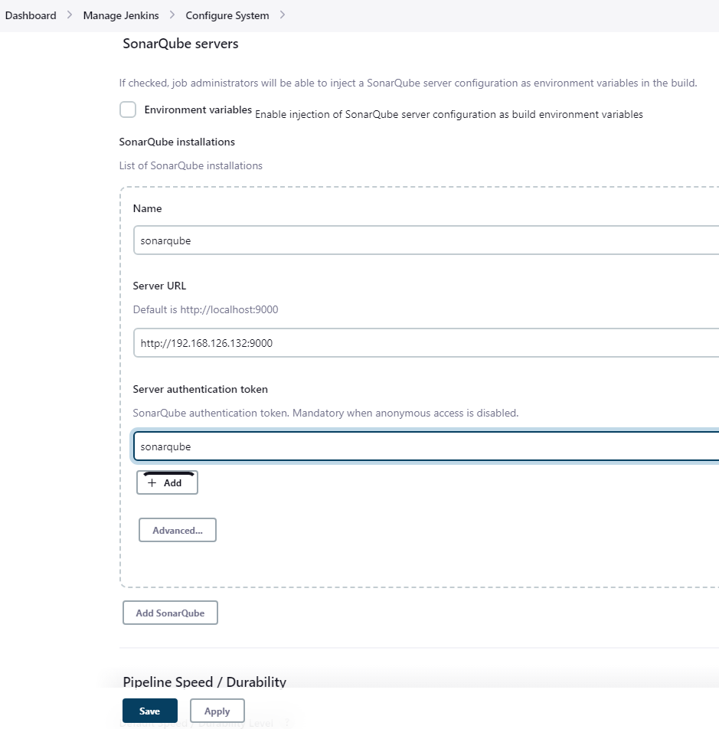

Click on the "Administration" button in the left-hand panel and select "Webhooks" from the dropdown menu.

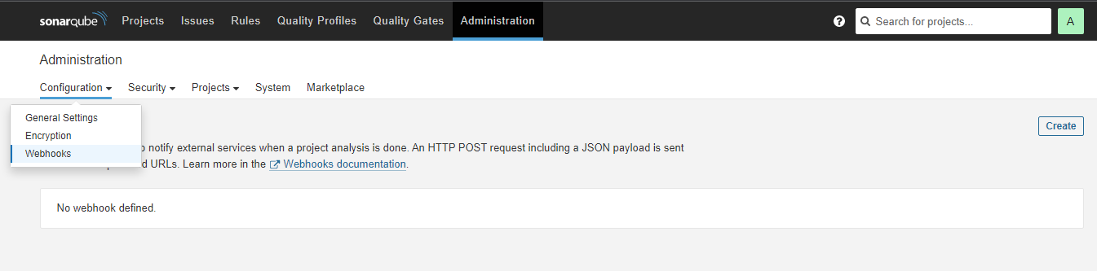

Click on the "Create" button to create a new webhook.

* + Enter a name for your webhook in the "Name" field.
  1. Enter the URL of the endpoint that will receive the webhook in the "URL" field.
  3. Click on the "Create" button to create the webhook.

That's it! Your SonarQube webhook is now created and will send data to the specified endpoint for the selected events.

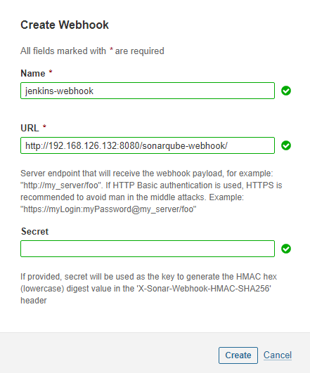

reference: <https://docs.sonarqube.org/latest/analyzing-source-code/scanners/jenkins-extension-sonarqube/>

Update stage

|  |
| --- |
| stage('SonarQube - SAST') {        steps {          withSonarQubeEnv('SonarQube') {            sh "mvn sonar:sonar -Dsonar.projectKey=numeric-application -Dsonar.host.url=http://devsecops-demo.eastus.cloudapp.azure.com:9000        }          timeout(time: 2, unit: 'MINUTES') {            script {              waitForQualityGate abortPipeline: true            }          }        }      } |

This is a Jenkins Pipeline stage that performs a static application security testing (SAST) scan using SonarQube.

The stage has the name 'SonarQube - SAST' and contains two steps:

* 1. The first step uses the withSonarQubeEnv function to set up the environment to use SonarQube, which is a tool used to analyze the code quality and security of the application. The configuration specifies the SonarQube instance to use by passing 'SonarQube' as the parameter.
  2. The second step runs a Maven command to execute the SonarQube analysis on the application code. The parameters passed to the command include the project key and the URL of the SonarQube instance.

The step also includes a timeout block that limits the execution time of the analysis to 2 minutes. After the analysis is completed, the waitForQualityGate function is used to wait for the quality gate to pass or fail.

If the quality gate passes, the pipeline continues to the next stage. If it fails, the pipeline is aborted and the build is marked as failed.

Build pipeline and I see it fail

numeric 
Overview Issues 
main O 
Security Hotspots 
March 8, 2023 version 
Measures 
Code Activity 
MEASURES 
New Code 
Since March 6, 2023 
Started 1 day ago 
- New augs 
Project Settings • 
QUALITY GATE STATUS O 
Failed 
1 conditims fäled 
The quality gate used by this project 
does not comply with Clean as You 
Code. 
Fixing this qualty qate will help you achieve a 
Clean Code state 
t? Leam why 
1 condition(s) failed on overall code 
13 Code Smells is greater than 12 
Overall Code 
Project Information 
Reliability 
Security 
0 
New Vulnerabilities 
New Security Hotspots O 
Added Debt 
Coverage on O New Lines to cover 
Reviewed 
New Code Smells 
Duplications on O New Lines 
Security Review 
Maintainability 

We need remove import code below to improve security:

import org.springframework.beans.factory.annotation.Autowired;

import org.springframework.beans.factory.annotation.Value;

import org.springframework.boot.web.client.RestTemplateBuilder;

import org.springframework.context.annotation.Bean;

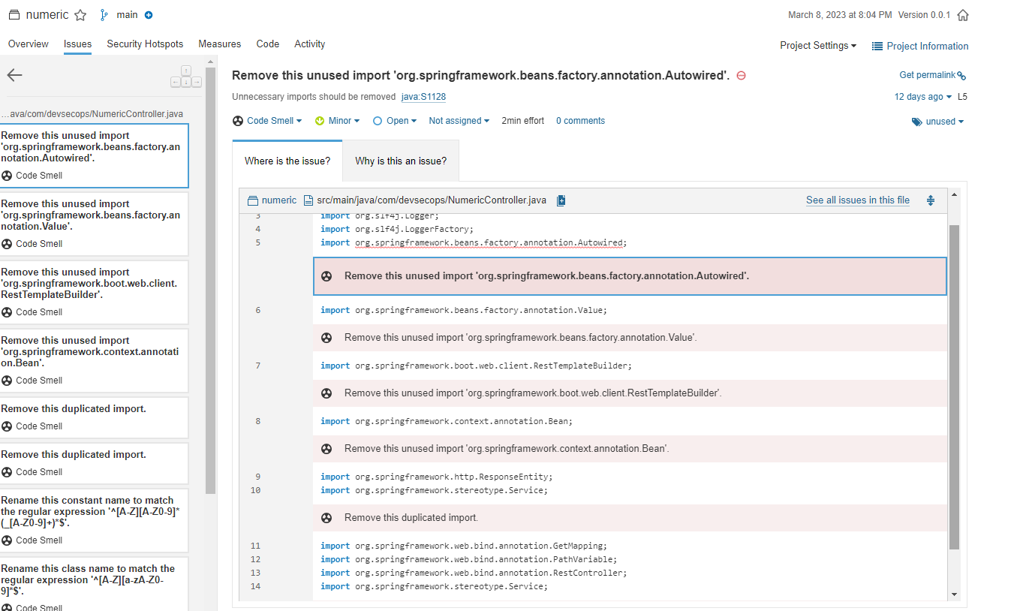

Build pipeline again

numeric 
main O 
Overview Issues Security Hotspots 
QUALITY GATE STATUS O 
Passed 
Al cmdtnns passed _ 
March 8, 2023 version 
Measures 
Code Activity 
MEASURES 
New Code 
Since March 6, 2023 
Started 1 day ago 
- New augs 
Project Settings • 
Overall Code 
The quality gate used by this project 
does not comply with Clean as You 
Code. 
Fixing this qualty qate will help you achieve a 
Clean Code state 
t? Leam why 
Project Information 
Reliability 
Security 
0 
New Vulnerabilities 
New Security Hotspots O 
Added Debt 
Coverage on O New Lines to cover 
Reviewed 
New Code Smells 
Duplications on O New Lines 
Security Review 
Maintainability 